

CLOUD COMPUTING LAB
BSE ( V-B )

Submitted By:
Musfira Farooq
Roll No:
2023-BSE-045
Submitted To:
Sir Muhammad Shoaib

LAB 10
GH CLI Codespaces + AWS + Terraform: VPC & Subnet Automation

Task 1 — GitHub CLI, Codespace setup and authentication
Objective: Install GH CLI, authenticate for Codespaces, and connect to a Codespace.
- Install GitHub CLI
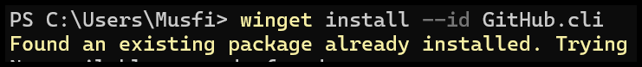
- GH CLI authentication for Codespaces
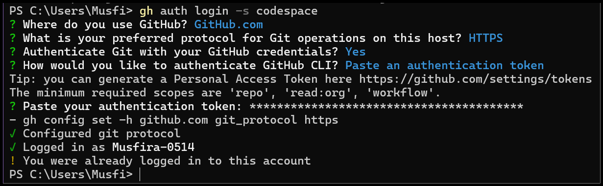
- List available Codespaces
- Connect to Codespace via SSH
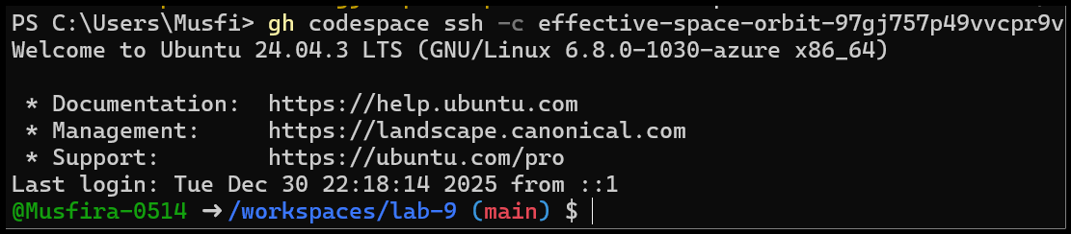
Task 2 — Install AWS CLI & Terraform, Provider Setup
Objective: Install AWS CLI & Terraform CLI and configure the Terraform provider.
- Terraform installation and version check
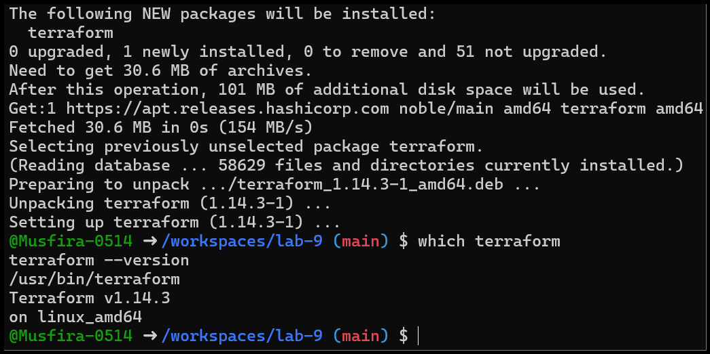
- Provider file creation (main.tf)
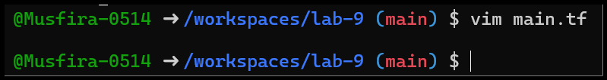
- Provider block configuration
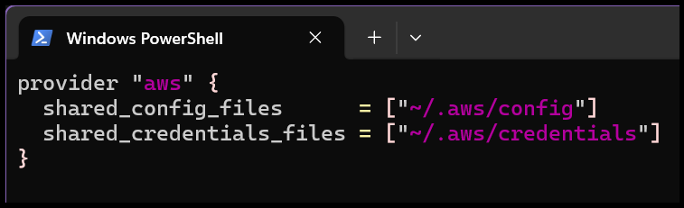
- Terraform initialization
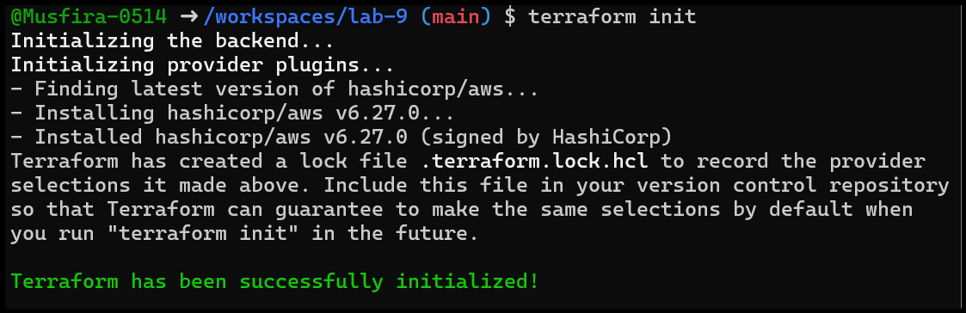
- Terraform lock file
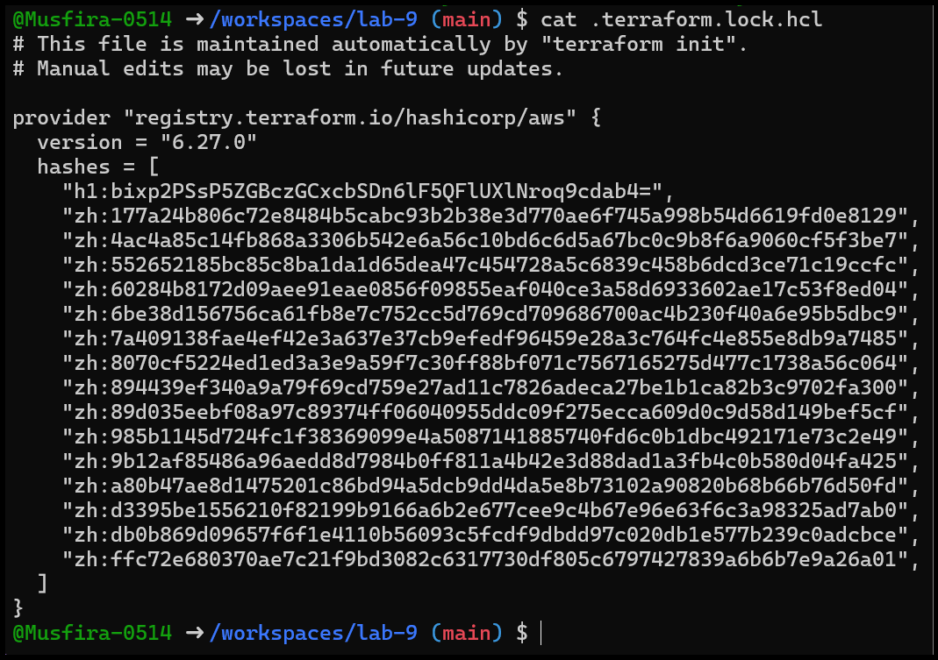
- Terraform directory structure
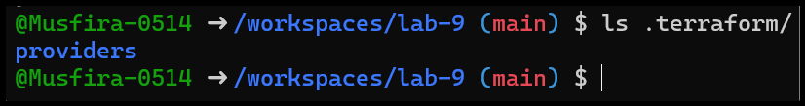
Task 3 — VPC & Subnet Creation Using Terraform
Objective: Create VPC and subnet resources and verify using AWS CLI.
- Add VPC & subnet resources to main.tf
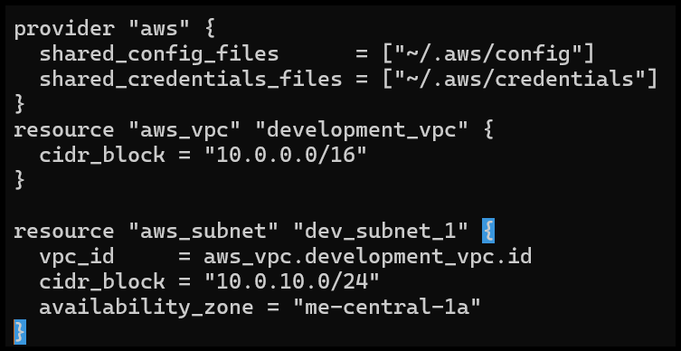
- Terraform apply — VPC & subnet creation
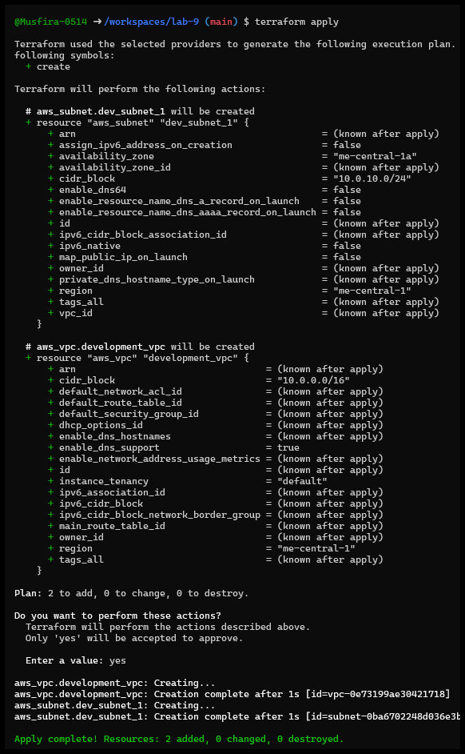
- Verify subnet using AWS CLI
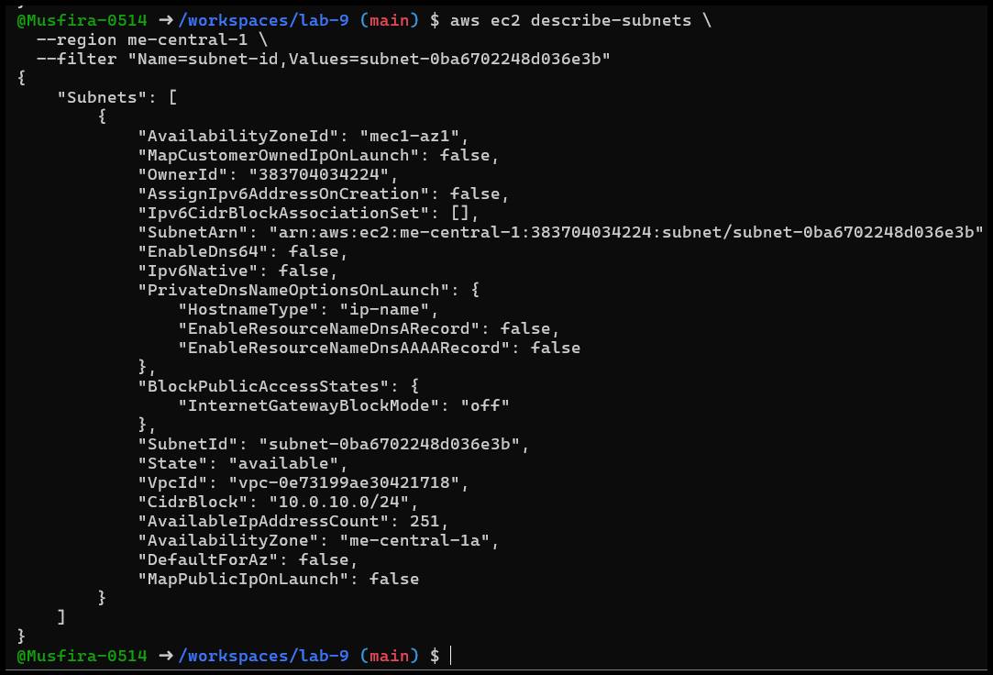
- Verify VPC using AWS CLI
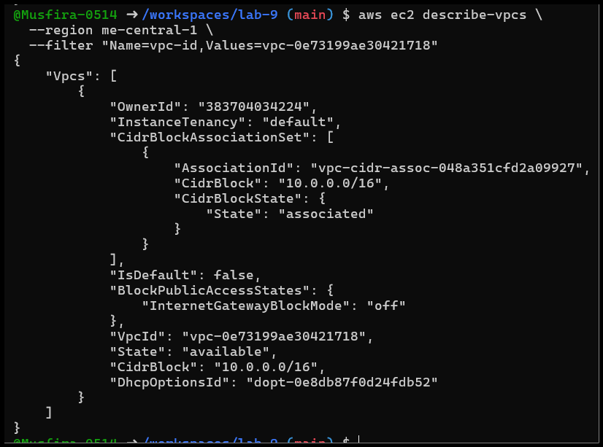
Task 4 — Data Sources, Targeted Destroy & Tagging
Objective: Use data sources, targeted destroy, refresh, and tagging.
- Add data source & resource in main.tf
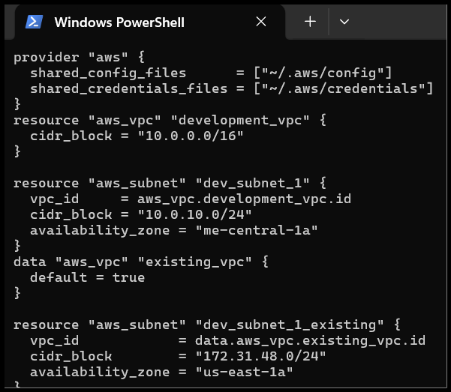
- Apply datasource-based resource
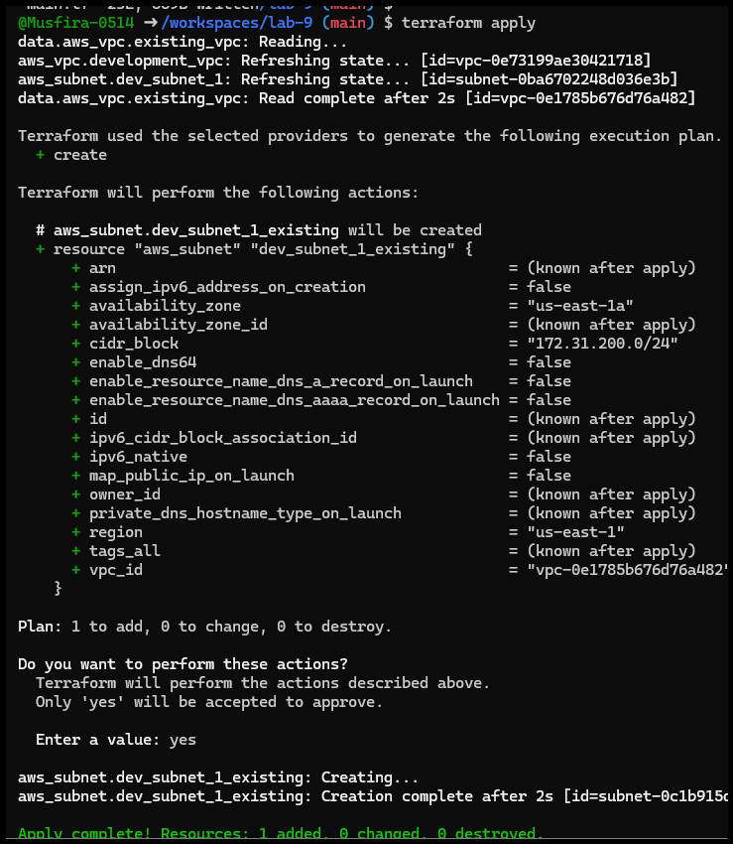
- Targeted destroy of subnet resource
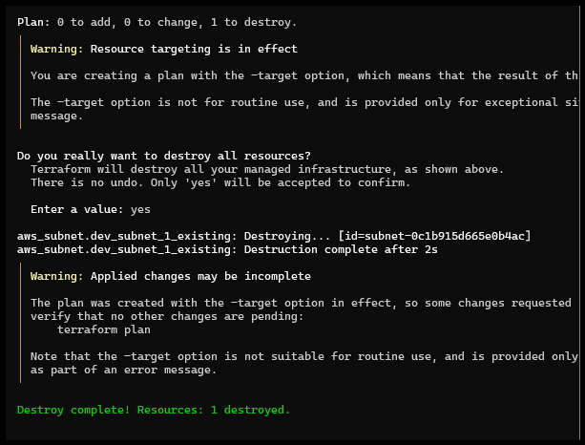
- Terraform refresh state
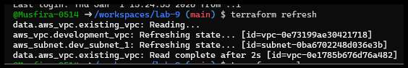
- Terraform apply after refresh
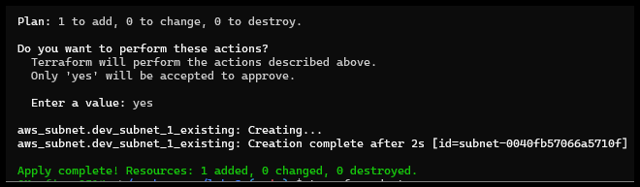
- Destroy all resources
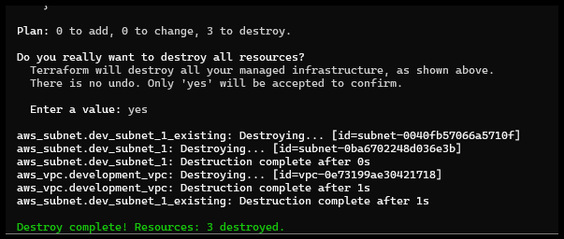
- Terraform plan output
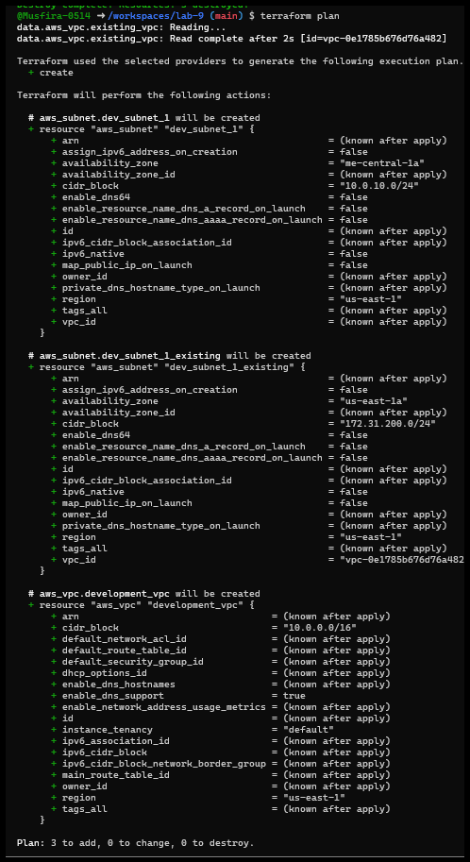
- Terraform apply after destroy
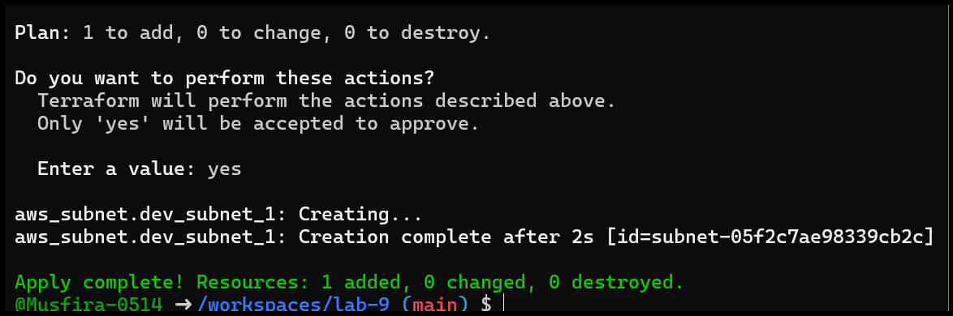
- Resource tagging in main.tf
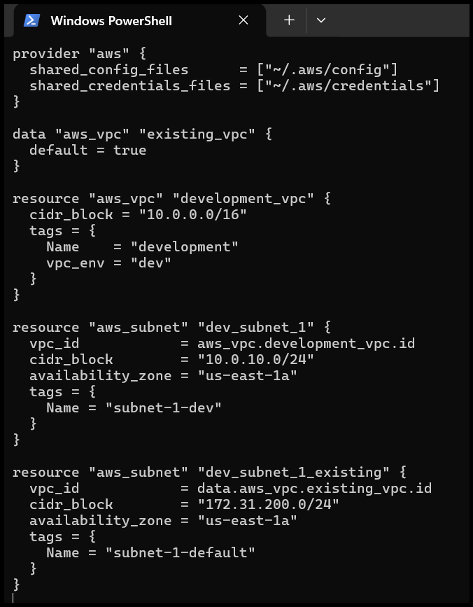
- Apply tagging changes
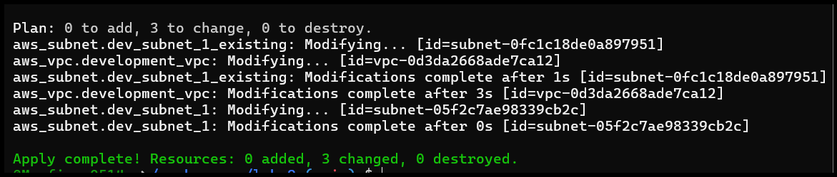
- Plan tag removal
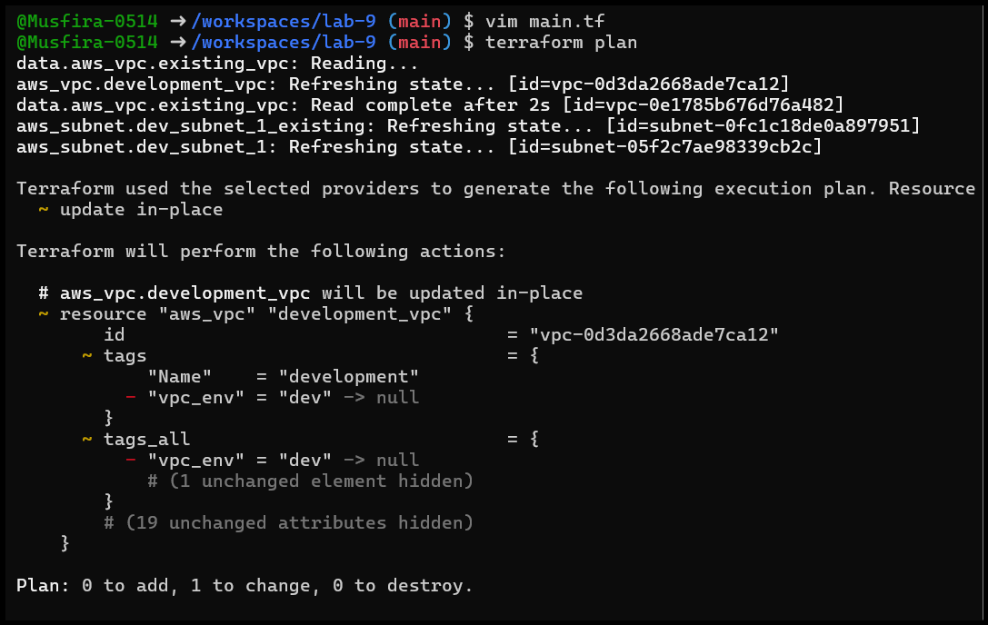
- Apply tag removal
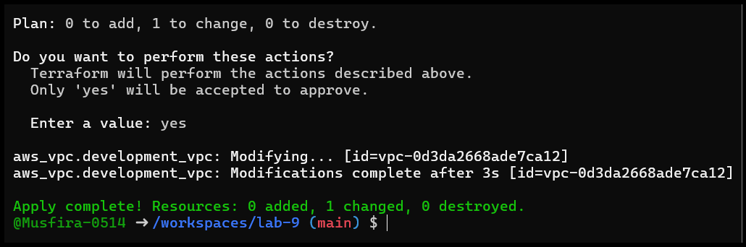
Task 5 — Terraform State File Inspection
Objective: Inspect Terraform state and backup files.
- Destroy all resources
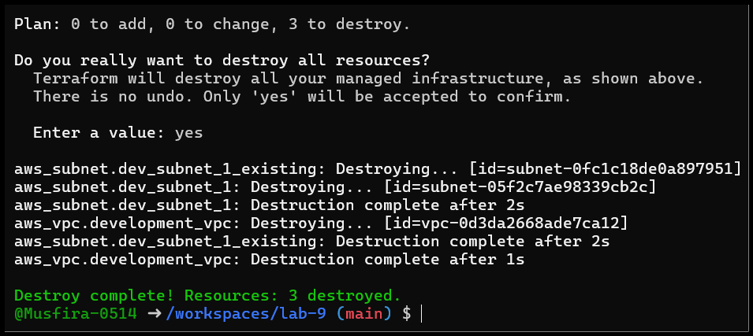
- Empty terraform.tfstate file
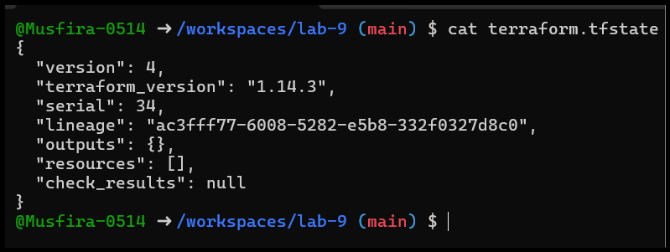
- terraform.tfstate.backup (previous state)
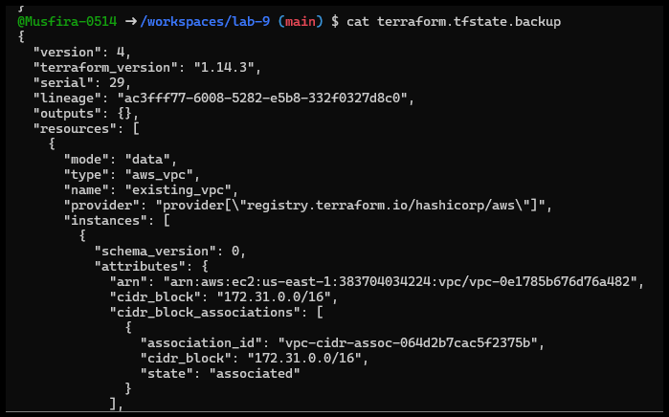
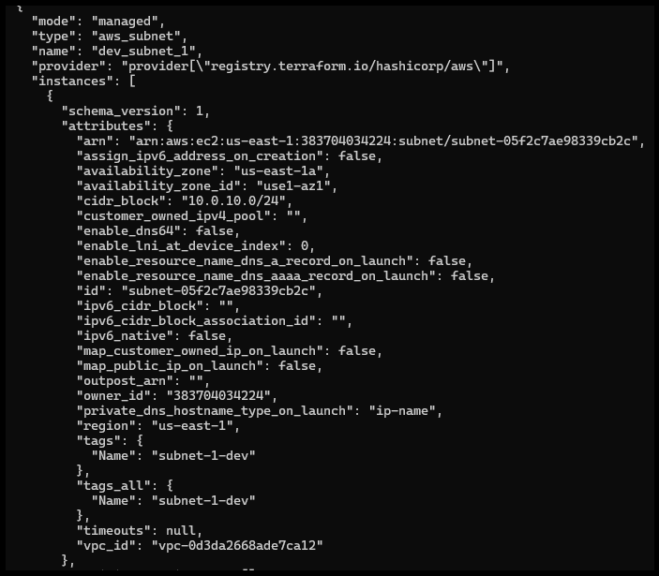
- Recreate resources using terraform apply
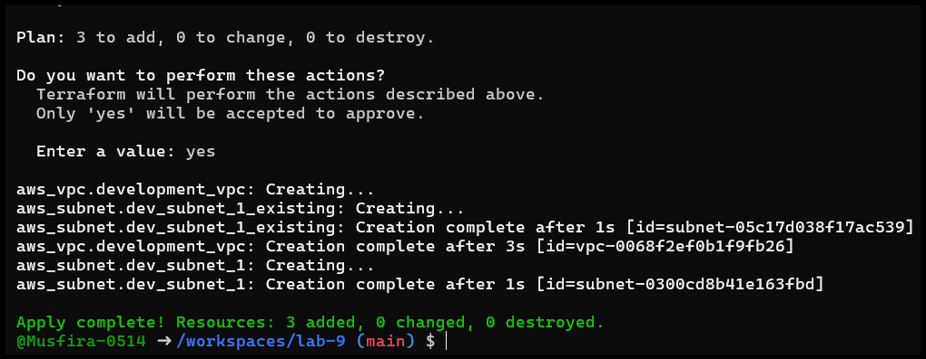
- Populated terraform.tfstate file
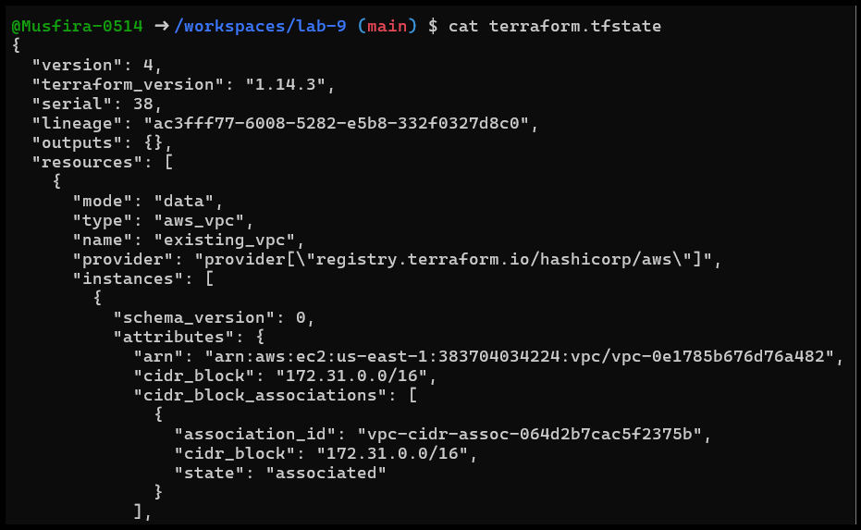
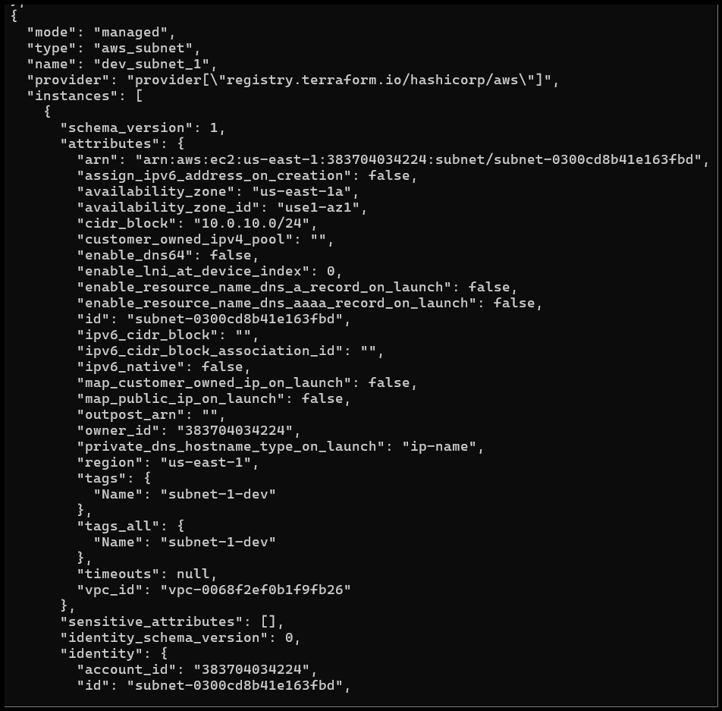
- Empty backup after restore
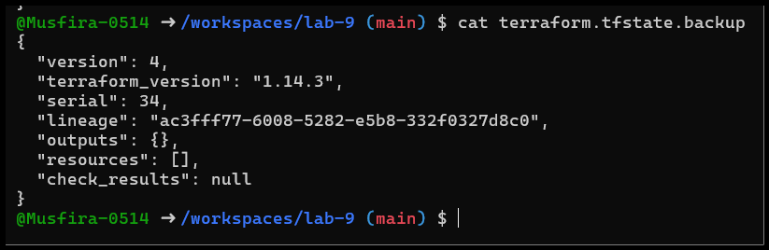
- Terraform state list
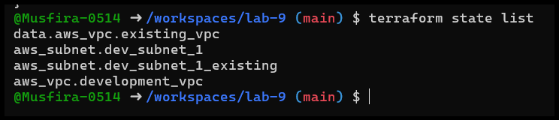
- Terraform state show resource
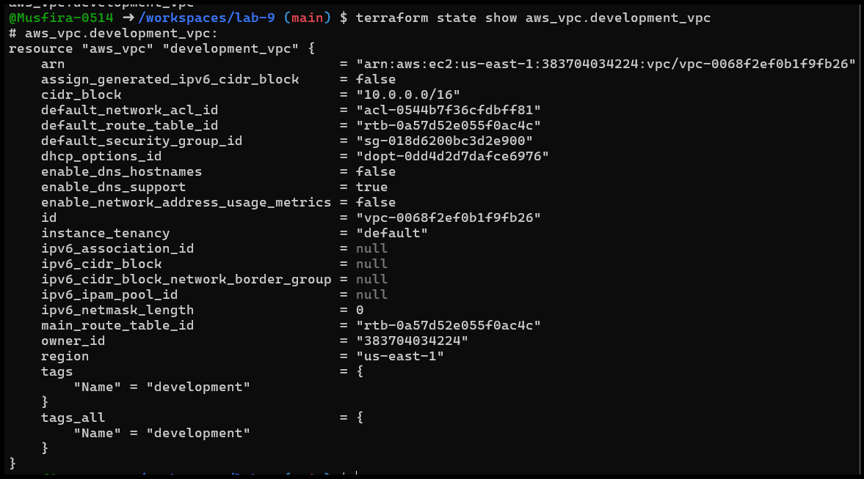
Task 6 — Terraform Outputs & Attributes
Objective: Extract and report resource attributes using Terraform outputs.
- Basic outputs (IDs & ARNs)
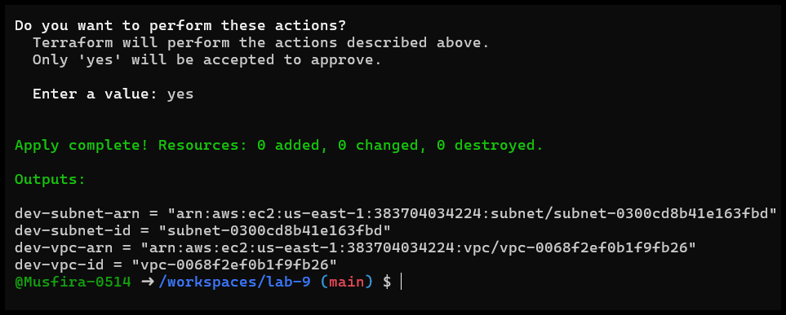
- Expanded outputs (CIDR, region, tags, tags_all)
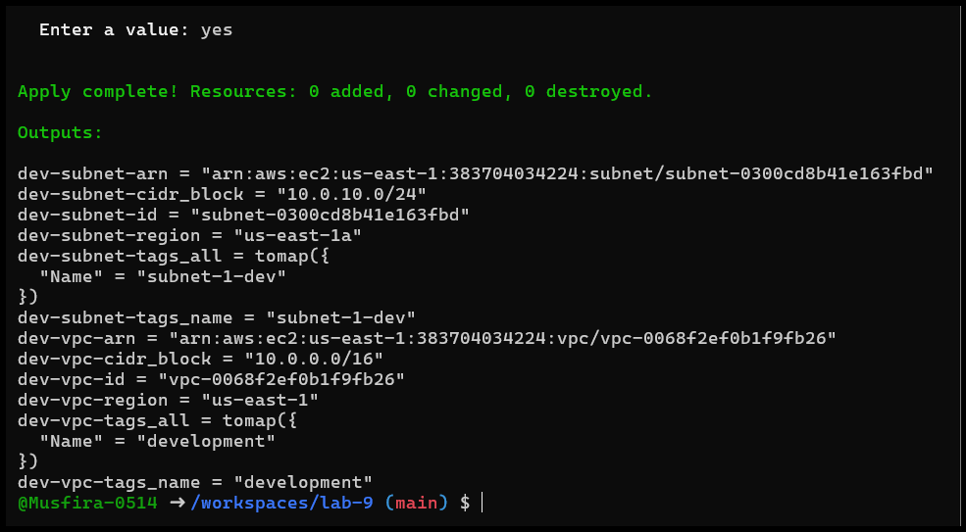
Cleanup — Remove All Resources & Verify State
- Destroy all Terraform-managed resources
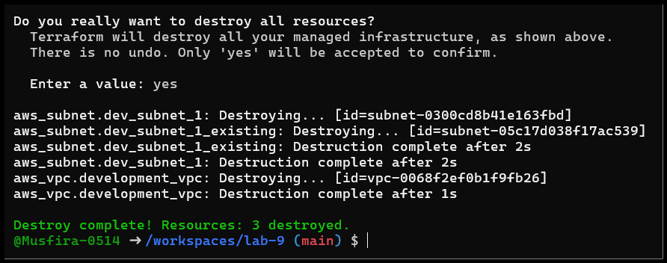
- Verify state files after cleanup
